**Project Design Phase-II**

**Data Flow Diagram & User Stories**

|  |  |
| --- | --- |
| Date | **14 October 2022** |
| Team ID | **PNT2022TMID48076** |
| Project Name | REAL TIME RIVER WATER QUALITY MONITORING AND CONTROLING SYSTEM |
| Maximum Marks | 4 Marks |

***Data Flow Diagrams:***

Also known as DFD, Data flow diagrams are used to **graphically represent the flow of data in a business information system**. DFD describes the processes that are involved in a system to transfer data from the input to the file storage and reports generation.Data flow diagrams can be divided into logical and physical. The logical data flow diagram describes flow of data through a system to perform certain functionality of a business. The physical data flow diagram describes the implementation of the logical data flow.

**Example: [(Simplified)](https://developer.ibm.com/patterns/visualize-unstructured-text/)**

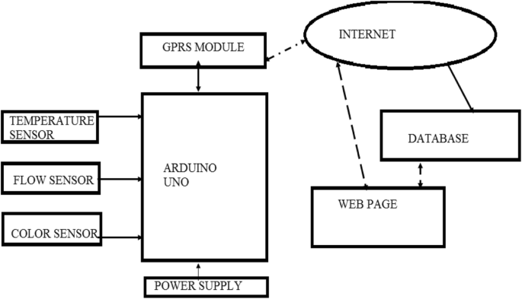

**DFD(Data Flow Diagrams)**

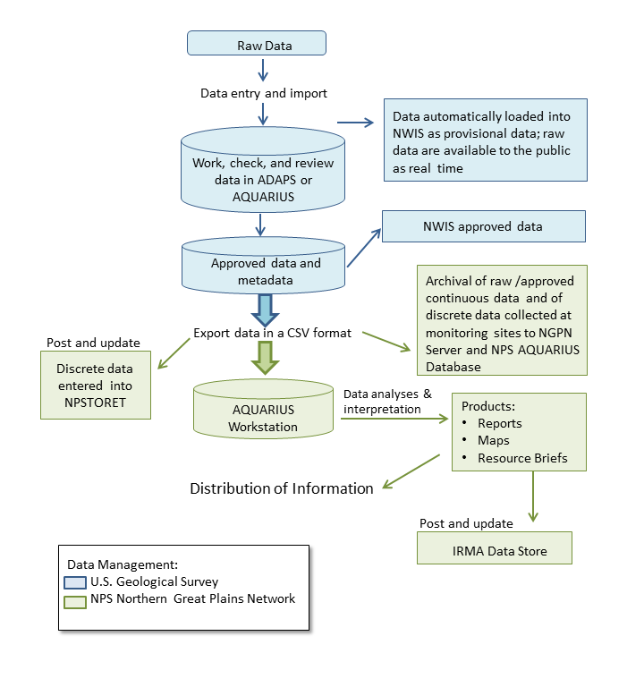

**Diagram for water Quality monitoring system:**

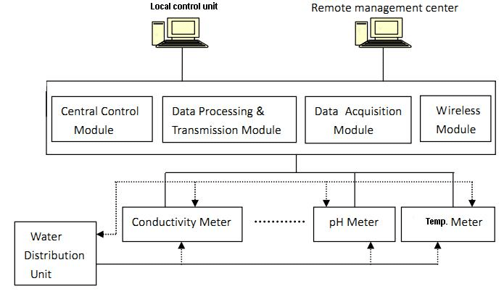

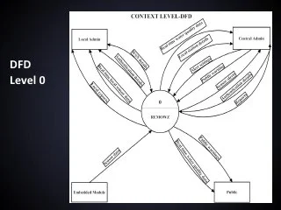

**DFD(Level 0)**

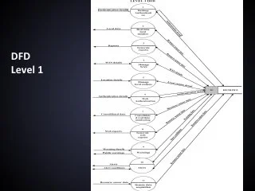

**DFD(level 1)**

**User Stories**

Use the below template to list all the user stories for the product.

| **User Type** | **Functional Requirement (Epic)** | **User Story Number** | **User Story / Task** | **Acceptance criteria** | **Priority** | **Release** |
| --- | --- | --- | --- | --- | --- | --- |
| Customer (Mobile user) | Registration | USN-1 | As a user, I can register for the application by entering my email, password, and confirming my password. | I can access my account / dashboard | High | Sprint-1 |
|  |  | USN-2 | As a user, I will receive confirmation email once I have registered for the application | I can receive confirmation email & click confirm | High | Sprint-1 |
|  |  | USN-3 | As a user, I can register for the application through Facebook | I can register & access the dashboard with Facebook Login | Low | Sprint-2 |
|  |  | USN-4 | As a user, I can register for the application through G mail |  | Medium | Sprint-1 |
|  | Login | USN-5 | As a user, I can log into the application by entering email & password |  | High | Sprint-1 |
| Customer (web user) | notification | USN-6 | As a user, When there is a abnormal situation  with the water notification will be received on  web application. | Alert message will be  received if user is active in  that web site | High | Sprint-1 |
| Customer Care Executive | Network connectivity | USN-7 | When a water quality contain high or low PH level it will indicate us. | Arduino Uno3 is used for testing water flow and quality. | High | Sprint-1 |
| Administrator | Accessing | USN-8 | When there is a issues in purity of water,it indicate through the device. | Operator informed to users. | medium | Sprint-2 |